
Cache Coherence

Presented by:
Nikesh Maharjan
Prerit Basnet

Date:July25,2018

Topics

- Cache Coherence

- Solution to Cache Coherence

- Hardware solution
- Directory protocols
- Snoopy protocols

- Software solution

Cache Coherence

In computer architecture, cache coherence is the uniformity of shared resource data that ends up stored in multiple local caches.

Requirements for cache coherence
Write Propagation
- Changes to the data in any cache must be propagated to other copies(of that cache line) in the peer caches.
Transaction Serialization
- Reads/Writes to a single memory location must be seen by all processors in the same order.

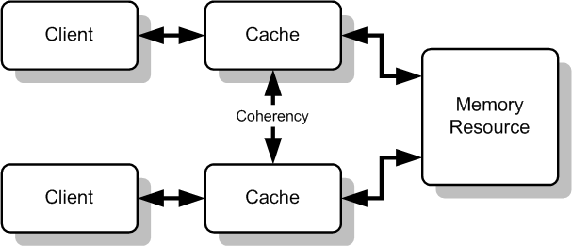

Solution to Cache Coherence Problem

Hardware Solution

It can be generally divided into two categories:

Directory Protocols
- It collects and maintain information about where copies of line reside.
- It contains the information about content of various local caches.
- It is responsible for keeping information up-to-date.

Drawback: works only for less buses,not suitable for large scale system.

Snoopy protocols

It is responsible for maintaining cache coherence among all of the cache controller in multiprocessor.

It has two basic approaches:

Write invalid protocol
- there can be multiple readers but only one writer at a time ,only one cache can write to the line.

Write update protocol
- there can be multiple writer as well as multiple readers

Software Solution

- It is software based protocol which rely on the compiler and operating system to deal with the problem.
- It performs an analysis on the code to determine which data items may become unsafe for caching and mark those time.
- It prevent any shared data variables from being cached.

Any Questions
?

Thank you!

